1. This program for real time calibration is based on Epanet secondary development, compiled by vs 2013. Before running the program, you need to install vs2013 or another version of visual studio.
2. There is a folder here named “real time Calibration Code for case 1”, which is the code for Case 1. Open a folder, double-click "RealtimeCalibration.sln" to start the program. The program interface after startup is shown in fig 1.

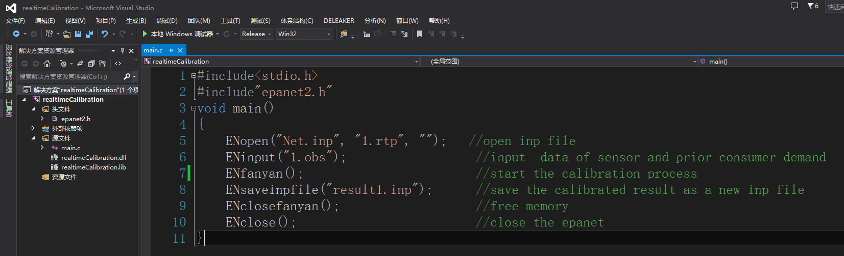

Fig 1. visual Studio startup interface

1. As can be seen from fig 1, two files named "×××.inp" and “×××.obs” are used as input to the program. The first file named "×××.inp" is the hydrualic model input file. The second file named “×××.obs” is used to store measured value and prior information of nodal demand. Both files are stored in the root folder.
2. "×××.obs" consist of five parts, namely [OBSERVETIME]， [TANK], [JUNCTIONS], [PIPES] and [JUNDEMANDS] which correspond to time of real-time data, reservoir discharge, pressure sensor value, flow sensor value and prior nodal demand. Each row of data contains three elements namely sensor id, measured value and standard deviation. The obs file for Case 1 is shown in fig 2.

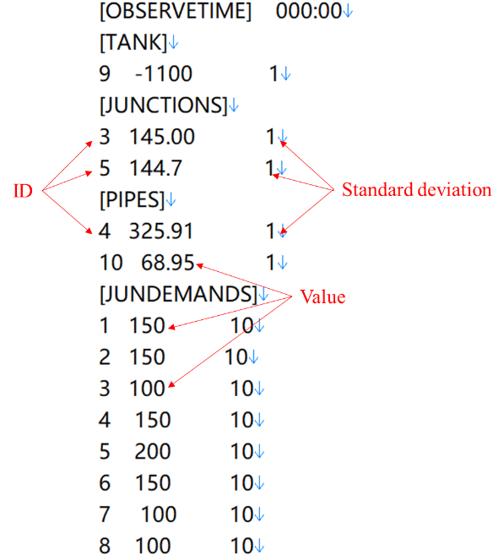

Fig 2 the obs file

1. The calibrated result (estimated consumer demand) is stored in a new inpfile which can be seen in fig 1.